**PSG CAS Library Science**

**MAJOR PROJECT REPORT**

Submitted by

**S. KAMALESH**

**19BCT019**

Under the Guidance of

**Dr. S. GEETHARANI MCA, MPhil, PhD,**

**Associate Professor & Head,**

Department of Computer Technology

In partial fulfillment of the requirements for the award of the degree of



**BACHELOR OF SCIENCE IN COMPUTER TECHNOLOGY**

Of Bharathiar University

**DEPARTMENT OF COMPUTER TECHNOLOGY**

**PSG COLLEGE OF ARTS & SCIENCE**

An Autonomous College-Affiliated to Bharathiar University

Accredited with A grade by NAAC (3rd Cycle)

College with Potential for Excellence

(Status Awarded by the UGC)

Star College Status Awarded by DBT - MST

An ISO 9001:2008 Certified Institution

Civil Aerodrome Post

Coimbatore - 641 014

**APRIL 2022**

**CERTIFICATE**

**DEPARTMENT OF COMPUTER TECHNOLOGY**

**PSG COLLEGE OF ARTS & SCIENCE**

An Autonomous College-Affiliated to Bharathiar University

Accredited with A grade by NAAC (3rd Cycle)

College with Potential for Excellence

(Status Awarded by the UGC)

Star College Status Awarded by DBT - MST

An ISO 9001:2008 Certified Institution

Civil Aerodrome Post

Coimbatore -641 014

**CERTIFICATE**

This is to certify that this Project work entitled **“PSG CAS Library Science”** is a bonafide record of work done by **S KAMALESH (19BCT019)** submitted to the PSG CAS in partial fulfillment of the requirements for the award of Degree of **Bachelor of Science in Computer Technology** of Bharathiar University.

Faculty Guide Head of the Department

Submitted for Viva-Voce Examination held on

Internal Examiner External Examiner

**DECLARATION**

**DECLARATION**

I, **KAMALESH S (19BCT019)**, hereby declare that this Project work entitled **“PSG CAS Library Science”**, is submitted to PSG College of Arts & Science (Autonomous), Coimbatore in partial fulfillment for the award of Bachelor of Science in Computer Technology, is a record of original work done by me under the supervision and guidance of **Dr. S. Geetharani MCA, MPhil, PhD** Associate Professor & Head of the Department of Computer Technology, PSG College of Arts & Science, Coimbatore.

This Project work has not been submitted by me for the award of any other Degree/ Diploma/ Associate ship/ Fellowship or any other similar degree to any other university.

PLACE : Coimbatore **KAMALESH S**

DATE : **(19BCT019)**

**ACKNOWLEDGEMENT**

**ACKNOWLEDGEMENT**

My venture stands imperfect without dedicating my gratitude to a few people who have contributed a lot towards the victorious completion for my project work.

I would like to thank **Mr L. Gopalakrishnan**, **Managing Trustee, PSG & Sons Charities**, for providing me a prospect and surroundings that made the work possible.

I take this opportunity to express my deep sense of gratitude to **Dr. T. Kannaian,** Secretary of PSG College of Arts and Science, Coimbatore for permitting and doing the needful towards the successful completion of this project.

I express my deep sense of gratitude and sincere thanks to our Principal **Dr. D. Brindha MSc, MPhil, PhD,** for her valuable advice and concern on students.

I am very thankful to **Dr. A Anguraj, MSc, MPhil, PhD, Vice Principal**, **Prof. M Umarani, MCom, MPhil, Faculty-In-Charge (Student Affairs)** for their support.

I kindly and sincerely thank **Dr. S. Geetharani MCA, MPhil, PhD,Associate Professor,Head of the Department of Computer Technology** for her whole hearted help to complete this project successfully by giving valuable suggestions.

This note of acknowledgement will be incomplete without paying my heartful devotion to my parents, my friends and other people, for their blessings, encouragement, financial support and the patience, without which it would have been impossible for me to complete the job.

**SYNOPSIS**

**SYNOPSIS**

**PSG CAS Library Science** is a Flexible Web Application, which is used for the scholars to post their journals via online. This application allows the User’s to submit their journals for review. On the other hand the web app enables the Admin, to approve or reject the journals submitted by the users.

This application is built in such a way, distinguished into three parts, one dealt with the User to post their journals. Another deals with the Super Admin to assign the journals submitted by the User’s to Admin’s (2).The Admin’s will review and update the status of their journals & the End user’s can view their status.

**TABLE OF CONTENTS**

**TABLE OF CONTENTS**

**CONTENTS PAGE NO.**

1. INTRODUCTION

2. SYSTEM SPECIFICATION

2.1. Hardware Specification

2.2. Software Specification

2.3. Software Description

3. SYSTEM ANALYSIS

4. MODULE DESCRIPTION

5. SYSTEM DESIGN

5.1. ER Diagram

5.2. Data Flow Diagram

5.3. Database Design

5.4. Input Design

5.5. Output Design

6. SYSTEM TESTING & IMPLEMENTATION

7. SCOPE FOR FUTURE ENHANCEMENTS

8. CONCLUSION

**BIBLIOGRAPHY**

**APPENDICES**

A. SCREEN SHOTS

B. SAMPLE CODING

1. **INTRODUCTION**
2. **Introduction**

**PSG CAS Library Science** is a Flexible Web Application, which is used for the scholars to post their journals via online. This application allows the User’s to submit their journals for review. On the other hand the web app enables the Admin, to approve or reject the journals submitted by the users.

This application is built in such a way, distinguished into three parts, one dealt with the User to post their journals. Another deals with the Super Admin to assign the journals submitted by the User’s to Admin’s (2).The Admin’s will review and update the status of their journals & the End user’s can view their status.

The primary aim of PSG CAS Library Science is ,

To develop a system for conscious, consistent and catalytic action to improve the academic and administrative performance of the institution.

To promote measures for institutional functioning towards quality enhancement through internalization of quality culture and institutionalization of best practices.

1. **SYSTEM SPECIFICATION**

**2. System Specification**

A System Requirements Specification (SRS) ( also known as a Software

Requirements Specification ) is a document or set of documentation that describes

the features and behavior of a system or software application. System specification means making an initial assessment or checking your system hardware and software capabilities.It is important and must be considered by every computer user to see if their desired software that needs to be installed can really accommodate or run on their hardware or devices.

**2.1 Hardware Specification**

**For Execution (PC)**

RAM : 2 GB

Processor : Intel i3 7th gen

Browsers : Chrome,Firefox,Opera,Edge,Inter Explorer etc.,

OS : Windows 10 Home

**For Execution (Android Mobile)**

RAM : 3 GB/higher

Processor : Any processor with more than 1GHz clock speed

Browsers : Chrome,Firefox,Opera,Edge,Inter Explorer etc.,

OS : Android Lollipop 5.0/higher

**2.2 Software Specification**

**Web Application**

This application was built using PERN(PostgreSQL,Express,React JS,Node js) Stack.

Platform used - Visual Studio

Web application front end - React Js

Web Application back end - Nodejs + Express

**Database**

Database/Server - Local Server

For Database - PostgreSQL

**2.3 Software Description**

**React Js**

React makes it painless to create interactive UIs. Design simple views for each state in your application, and React will efficiently update and render just the right components when your data changes.Declarative views make your code more predictable and easier to debug.Build encapsulated components that manage their own state, then compose them to make complex UIs.Since component logic is written in JavaScript instead of templates, you can easily pass rich data through your app and keep state out of the DOM. We don’t make assumptions about the rest of your technology stack, so you can develop new features in React without rewriting existing code.

**Node Js**

As an asynchronous event-driven JavaScript runtime, Node.js is designed to build scalable network applications. In the following "hello world" example, many connections can be handled concurrently. Upon each connection, the callback is fired, but if there is no work to be done, Node.js will sleep.

This is in contrast to today's more common concurrency model, in which OS threads are employed. Thread-based networking is relatively inefficient and very difficult to use. Furthermore, users of Node.js are free from worries of dead-locking the process, since there are no locks. Almost no function in Node.js directly performs I/O, so the process never blocks except when the I/O is performed using synchronous methods of Node.js standard library. Because nothing blocks, scalable systems are very reasonable to develop in Node.js.

**Express Js**

Express is a minimal and flexible Node.js web application framework that provides a robust set of features for web and mobile applications.With a myriad of HTTP utility methods and middleware at your disposal, creating a robust API is quick and easy.Express provides a thin layer of fundamental web application features, without obscuring Node.js features that you know and love.Many popular frameworks are based on Express.

**PostgreSQL**

PostgreSQL comes with many features aimed to help developers build applications, administrators to protect data integrity and build fault-tolerant environments, and help you manage your data no matter how big or small the dataset. In addition to being free and open source, PostgreSQL is highly extensible.

For example, you can define your own data types, build out custom functions, even write code from different programming languages without recompiling your database.

PostgreSQL tries to conform with the SQL standard where such conformance does not contradict traditional features or could lead to poor architectural decisions. Many of the features required by the SQL standard are supported, though sometimes with slightly differing syntax or function. Further moves towards conformance can be expected over time. As of the version 14 release in September 2021, PostgreSQL conforms to at least 170 of the 179 mandatory features for SQL:2016 Core conformance. As of this writing, no relational database meets full conformance with this standard.

1. **SYSTEM ANALYSIS**

**3. System Analysis**

This System involves studying a procedure or business to identify its goals and purposes and create systems and procedures that will efficiently achieve them. Use cases are a widely used systems analysis modeling tool for identifying and expressing the functional requirements of a system. Systems analysis is the process by which an individual (s) studies a system such that an information system can be analyzed, modeled, and a logical alternative can be chosen. Systems analysis projects are initiated for three reasons: problems, opportunities, and directives.

It is a process of collecting and interpreting facts, identifying the problems, and decomposition of a system into its components. System analysis is conducted for the purpose of studying a system or its parts in order to identify its objectives. It is a problem solving technique that improves the system and ensures that all the components of the system work efficiently to accomplish their purpose.

Systems analysis professionals are often called upon to look critically at systems, and redesign or recommend changes as necessary. Inside and outside of the business world, systems analysts help to evaluate whether a system is viable or efficient within the context of its overall architecture, and help to uncover the options available to the employing business or other party.

Systems analysts are different than systems administrators, who maintain systems day to day, and their roles generally involve a top-level view of a system to determine its overall effectiveness according to its design.

1. **MODULE DESCRIPTION**

**4. Module Description**

**PSG CAS Library Science** involves three modules such as :

**a) End User**

This side of the web application is used by the users who can post their journals by creating an account & it will be authenticated using email & password. The authenticated users will be moved to the dashboard and there they can post their journals and can also check their status of the submitted journals.

**b) Super Admin**

Here the Super Admin (i.e Librarian) will allocate the journals posted by the users to the Admins for review. Two admins will be allocated for each journal and there should not be same admin for one journal.

**c) Admin**

Once the super admin allocates the journal to the admin, the admin will review the journal posted by the End user and will leave a comment for them and the End users can check the check the status of their journal.

1. **SYSTEM DESIGN**

**5. System Design**

**5.1 Entity Relationship Diagram**

An entity-relationship (ER) diagram is a specialized graphic that illustrates the relationships between entities in a database. ER diagrams often use symbols to represent three different types of information. Boxes are commonly used to represent entities. Diamonds are normally used to represent relationships and ovals are used to represent attributes. An entity relationship diagram (ERD) is a data modeling technique that graphically illustrates an information system‟s entities and the relationships between those entities. An ERD is a conceptual and representational model of data used to represent the entity framework infrastructure.

**ER Diagram Symbols**



**Steps involved in creating an ERD include:**

* Identifying and defining the entities
* Determining all interactions between the entities
* Analyzing the nature of interactions/determining the cardinality of the relationships.
* Creating the ERD.

User

volumes

review

View Details

Submit Journals

files

**5.2 Data Flow Diagram**

A data flow diagram (DFD) illustrates how data is processed by a system in terms of in terms of input and output. As its name indicates its focus is on the flow of information, where data comes from, where it goes and how it gets stored. It uses defined symbols like rectangles, circles and arrow, plus short text labels, to show data inputs, outputs, storage points and the routes between each destination. A data flow diagram (DFD) maps out the flow of information for any process or system. It uses defined symbols like rectangles, circles and arrows, plus short text labels, to show data inputs, outputs, storage points and the routes between each destination.

 Data flowcharts can range from simple, even hand-drawn process overviews, to in-depth, multi-level DFDs that dig progressively deeper into how the data is handled. They can be used to analyze an existing system or model a new one. Like all the best diagrams and charts, a DFD can often visually “say” things that would be hard to explain in words, and they work for both technical and nontechnical audiences, from developer to CEO. That’s why DFDs remain so popular after all these years. While they work well for data flow software and systems, they are less applicable nowadays to visualizing interactive, real-time or database-oriented software or systems.

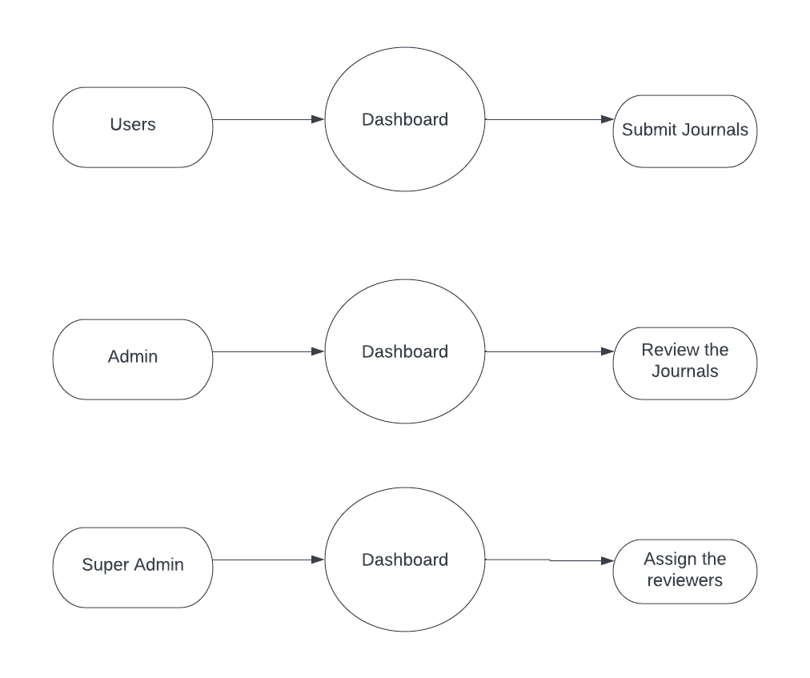**Level - 0**

**Level - 1**

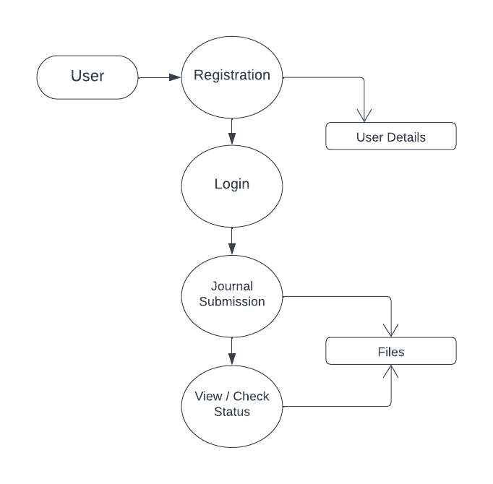

**Level - 2**

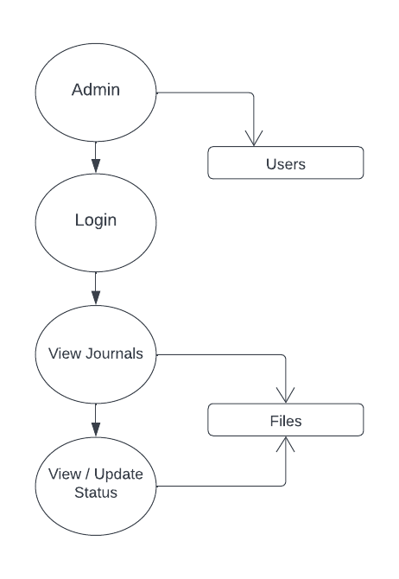

**Level – 3**

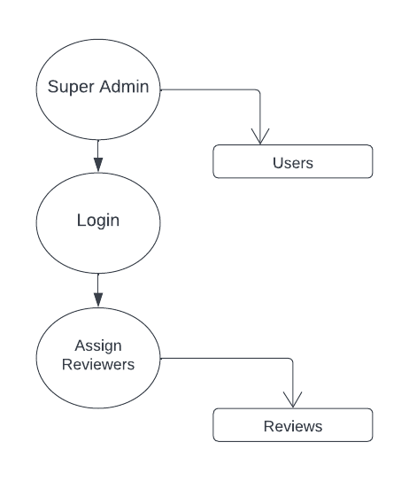

**5.3 Database Design**

Database design can be generally defined as a collection of tasks or processes that enhance the designing, development, implementation, and maintenance of enterprise data management system. Designing a proper database reduces the maintenance cost thereby improving data consistency and the cost-effective measures are greatly influenced in terms of disk storage space. Therefore, there has to be a brilliant concept of designing a database. The designer should follow the constraints and decide how the elements correlate and what kind of data must be stored.

The main objectives behind database designing are to produce physical and logical design models of the proposed database system. To elaborate this, the logical model is primarily concentrated on the requirements of data and the considerations must be made in terms of monolithic considerations and hence the stored physical data must be stored independent of the physical conditions. On the other hand, the physical database design model includes a translation of the logical design model of the database by keep control of physical media using hardware resources and software systems such as Database Management System (DBMS).

**Table 1 :** Users

|  |  |  |  |
| --- | --- | --- | --- |
| Field Name | Size | Data type | Constrain |
| Email | 100 | VARCHAR | Primary Key |
| Name | 100 | VARCHAR | Not Null |
| User Id | 100 | VARCHAR | Not Null |
| Roll | 100 | VARCHAR | Not Null |
| Password | 100 | VARCHAR | Not Null |

**Table 2 :** Files

|  |  |  |  |
| --- | --- | --- | --- |
| Field Name | Size | Data type | Constrain |
| Name | 100 | VARCHAR | Not Null |
| User Id | 100 | VARCHAR | Foreign Key |
| Date | 100 | VARCHAR | Not Null |
| Status | 100 | VARCHAR | Not Null |
| File | 100 | VARCHAR | Not Null |
| Title | 100 | VARCHAR | Not Null |

**Table 3** : Reviews

|  |  |  |  |
| --- | --- | --- | --- |
| Field Name | Size | Data type | Constrain |
| File Id | 100 | VARCHAR | Primary Key |
| User Id | 100 | VARCHAR | Foreign Key |
| Author | 100 | VARCHAR | Not Null |
| reviewer 1 | 100 | VARCHAR | Not Null |
| reviewer 2 | 100 | VARCHAR | Not Null |
| r1_status | 100 | VARCHAR | Not Null |
| r2_status | 100 | VARCHAR | Not Null |
| r1_email | 100 | VARCHAR | Not Null |
| r2_email | 100 | VARCHAR | Not Null |
| r1_comment | 100 | VARCHAR | Not Null |
| r2_comment | 100 | VARCHAR | Not Null |

**Table 4** : Volumes

|  |  |  |  |
| --- | --- | --- | --- |
| Field Name | Size | Data type | Constrain |
| file_id | 100 | VARCHAR | Not Null |
| file | 100 | VARCHAR | Foreign Key |
| volume No | 100 | VARCHAR | Not Null |
| no | 100 | VARCHAR | Not Null |
| file no | 100 | VARCHAR | Not Null |
| year | 100 | VARCHAR | Not Null |

**5.4 Input design**

Input design is the process of converting the user-oriented input to a computer based format. The goal of the input design is to make the data entry easier, logical and free error. Errors in the input data are controlled by the input design. The quality of the input determines the quality of the system output. Input design is one of the most important phases of the system design.

Input design is the process where the input received in the system are planned and designed, so as necessary. The aim of the input design is to ensure the maximum possible levels of accuracy and also ensure that the input is accessible and understood by the user.

**5.5 Output Design**

The output design was done so that result of processing could be communicate to the users. The various output have designed in such a way that they represent the same format that the office and management. Computer output is the most important and direct source of information to the user efficient intelligible output design should improve the system relationship with the user and help in decision making.

A major form of output is hardcopy from the printer. Output requirements are designed during system analysis. A good starting point for the output design is the data flow diagram (DFD). Human factors issues for design involves addressing internal controls to ensure readability.

1. **SYSTEM TESTING AND IMPLEMENTATION**

**6. System Testing and Implementation**

**Testing and Implementation**

It is the stage of implementation, which ensures that system works accurately and effectively before the live operation commences. It is a confirmation that all are correct and opportunity to show the users that the system must be tested with the text data and show that the system will operate successfully and produce expected results under expected conditions.

**White Box Testing**

* By using this technique it was tested that all the individual logical paths were executed at least once.
* All the logical decisions were tested on both their true and false sides.
* All the loops were tested with the data in between the ranges and especially at the boundary values.

**Black Box Testing**

* By the use of these technique the missing functions are identified and placed in their positions.
* The errors in the interfaces were identified and corrected.
* This technique was also used to identify the initialization and termination errors and correct them.

Testing is vital to the parts of the system are correct; the goal will be successfully achieved. Inadequate testing or non-testing leads to errors that may not appear until this months later. The effort of system errors on files and records within the system. A small system error can conceivably exploded into much larger problem. Effectively early in the process translates directly into long term cost savings from a reduced number of errors.

**Unit Testing**

Unit tests perform basic test at component level and test a specific business process, application, and /or system configuration. Unit tests ensure that each path of a business process performs accurately to the documented specifications, functionality and contains clearly defined inputs and expected results.

**Validation Testing**

Validation succeeds when the developed system functions as per the

requirement of the customer. Application validation is achieved through a series of black box that demonstrate the conformity with the requirements. Deviations or errors in this steps are corrected.

**Output Testing**

Various outputs has been generated by the system. The system generated output and the desk-calculated values have been compared. All the output is 35 perfect as the company desires. It begins with the low volumes of transactions based on live tone. The volume is increased until the maximum level for each transaction type is reached. The total system is also tested for recovery and fall back, after various major failures to ensure that no data are lost during the emergency time.

**Integration Testing**

Integration tests are done to test integrated application components were individually satisfactory, as shown by successful unit testing; the combination of components is correct and consistent.

**System Implementation**

System implementation is the stage of the project when the theoretical design is turned into a working system. If the implementation stage is not correctly planned and controlled, it can be choice. The following are the main stages in the implementation:

* Planning
* Training
* Maintenance

**Planning**

Planning plays an important role in the implementation. The planning should face any practical problems of controlling various activities of people out their own data processing department.

**Training**

Successful implementation needs trained computer staff. So some staff can teach them about the computer implementation, which only then becomes a well designed system.

**Maintenance**

Maintenance involves recovery on crash such as the backups and the end user should be given only executable format of the system.

1. **SCOPE FOR FUTURE ENHANCEMENTS**

**7. Scope For Future Enhancements**

As everything has been made online after the development of technology in all the sectors, in the side of educational sector too, classes and examinations are as well taking place through online. Most probable every part of work moved digitalized that makes work flexible & easy.It reduces our manual work.So,this web app would be very useful for the staffs to collect all reports via online.

The project has a very vast scope in future. The project can be implemented on intranet in future. Project can be updated in near future as and when requirement for the same arises, as it is very flexible in terms of expansion. With the proposed software of database Space Manager ready and fully functional is now able to manage and hence run the entire work in a much better, accurate and error free manner.

1. **CONCLUSION**

**8. CONCLUSION**

**PSG CAS Library Science** is a Flexible Web Application, which is used for the scholars to post their journals via online. This application allows the User’s to submit their journals for review. On the other hand the web app enables the Admin, to approve or reject the journals submitted by the users.

**BIBLIOGRAPHY**

**BIBLIOGRAPHY**

**Website Reference**

* https://reactjs.org/
* https://www.w3schools.com/sql/
* https://youtube.com**/online_tutorials**